Name: __________________ Period: ___ Date:______

Chapter 9 Lewis and Clark Expedition Writing Prompt
Directions: Write a 5 sentence paragraph:
Each sentence should identify a non-living item you would take on the expedition and why you would take it. Underline each item when you first identify it in the journal. Make sure to include a drawing in your entry of one of the items you chose.
Items must be appropriate for the existing technology of the early 1800’s.
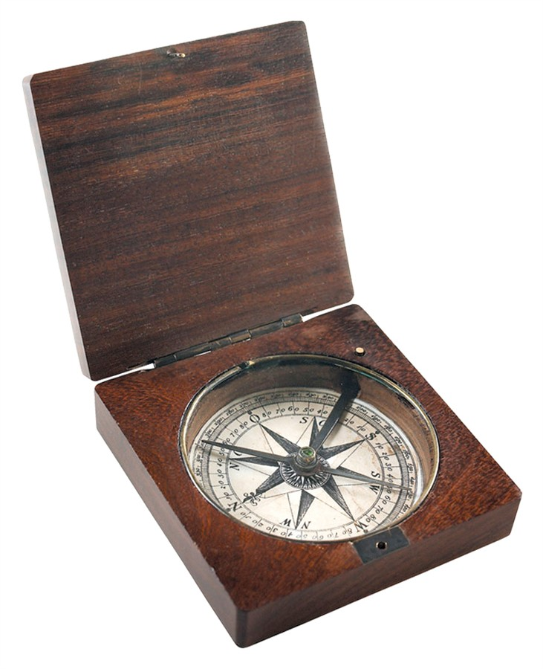
Clark’s Compass

Grading:
Each sentence = 2 pts (must be complete and on task sentence)
Information = 5 pts (must include all necessary info)

Total: /15 points

Name: __________________ Period: ___ Date:______

Chapter 9 Lewis and Clark Expedition Writing Prompt
Directions: Write a 5 sentence paragraph:
Describe an animal that the Lewis and Clark expedition encountered that did not exist back east. Make sure to include a drawing in your entry of the animal.
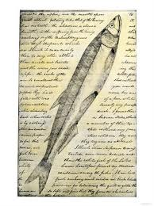
Journal Page of Meriwether Lewis

Grading:
Each sentence = 2 pts (must be complete and on task sentence)
Information = 5 pts (must include all necessary info)

Total: /15 points

Lewis and Clark Quiz
- Identify one goal of the expedition.
- Identify another goal of the expedition.
- What city did the expedition start from?
- What was one major geographical challenge the expedition faced?
- Who acted as an interpreter/guide for the expedition?

